**Leela Sai Lokesh G**

**RA2011028010100**

**Task-2**

**System Architecture Diagram:**

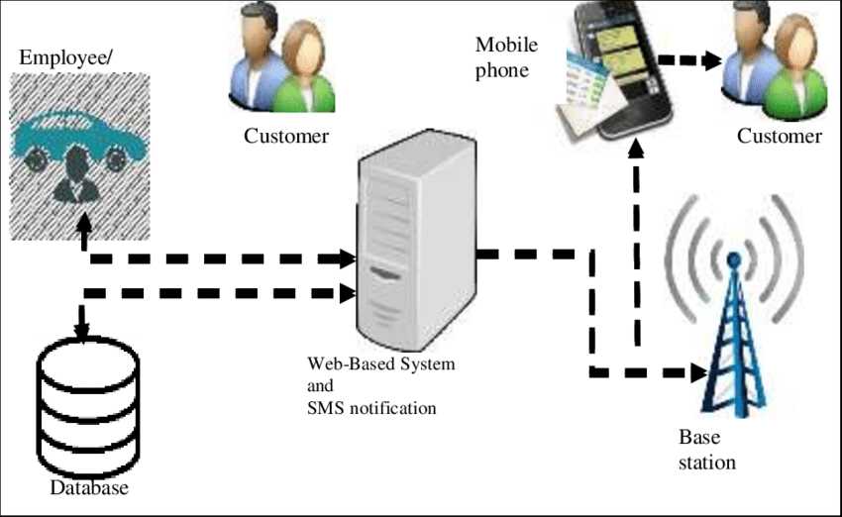

A system architecture diagram **abstracts the relationships, restrictions, and boundaries between components of a software system**. It's a crucial tool that provides a comprehensive overview of the software system's physical deployment and development roadmap. An architectural diagram must perform a variety of tasks.

Here, Every thing is interconnected with Web-Based System and SMS notification as it is the most vital functions among all the features. Only database and notifications are inter-communicable. Once the data is uploaded in database then the information is reached to customer in such away that first sent to base station as an intermediate device. Thereby reached to mobile then to customer.

**Activity Diagram:**

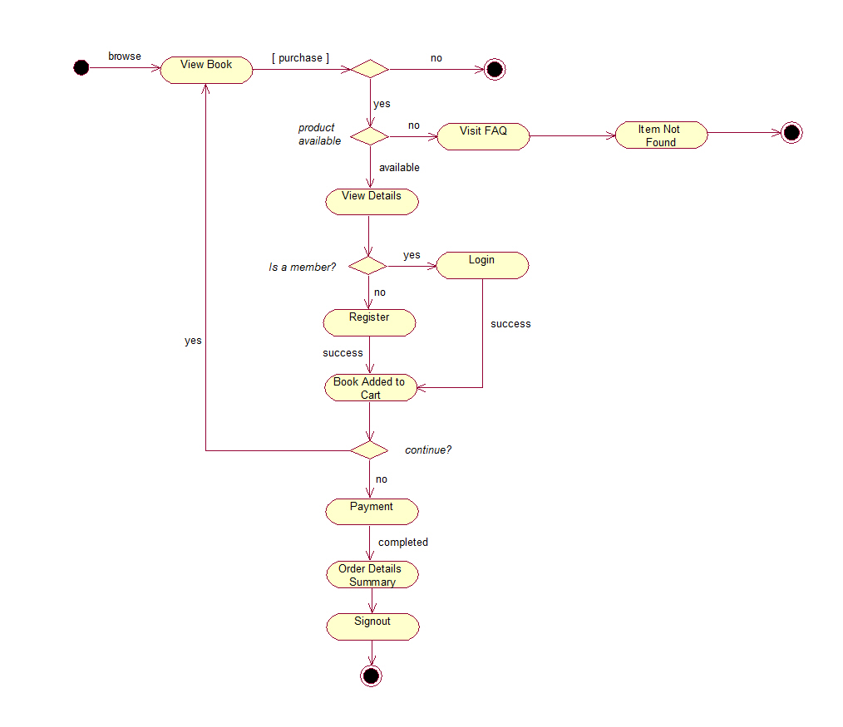

**Use Case Diagram:**

